Project: Library Management System

Author: Zhuoming Wu(zw3762), Yi Cui(yc6211)

Tech Stack: Servlet, Java Server Page(jsp), c3p0 for database connections, BdUtils, BeanUtils. MD5 for hashing

Environment: JDK 1.8, tomcat 8.5, Mysql 5.7, eclipse IDE, Navicat.

Project Description: (See the demo Video for more comprehensive description.)

We built up a Library Management System to help to manage books and readers. As a reader, you could log into the system and search the desired book you want. You could also see the popular book recommendation to see what books you want. Once you find the desired book, you could borrow this book and it would be shown in the Borrowing Information. And once you returned this, this would be shown in Borrowing History. Also, as a reader, you could see the Best Readers part to see who rented the most books, and give feedback through Feedback options. As an administrator, you could log in as an admin user to manage readers and books. You could add a new book, delete and change a current book, and modify the book's genre.

Step to run our project:

Environment: Eclipse IDE, tomcat 8.5, Mysql, Navicat.

1. Import project through eclipse
2. Set up database, we used Navicat

* Create connections: Host:localhost, Port 3306, User Name: root, password: root
* Create database named books. Execute the SQL file named books.sql in to set up database.
* Connect them (Turn green light in Navicat)

1. In eclipse, right click the project name and get into “properties” page, in project facets, make sure “Dynamic Web Module”, “Java”,

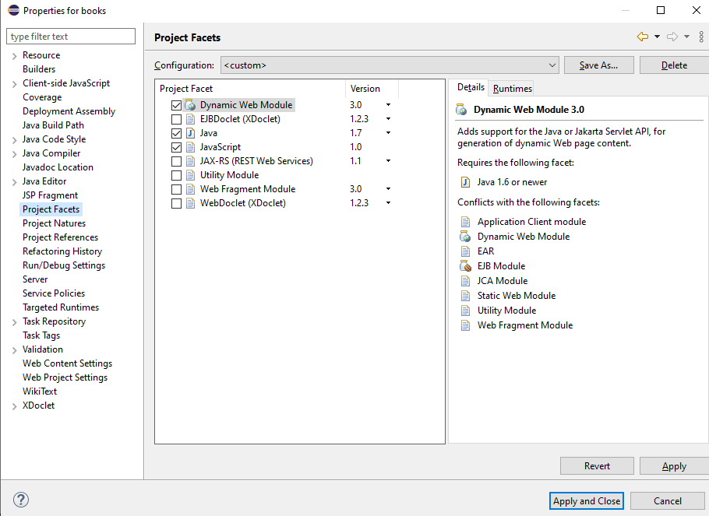

1. Then also in “Properties”, in Java Build Path Page, Add libraries named “Server Runtime” and choose the tomcat version you have (8.5 in my case)
2. Create servers in “Servers” tab, 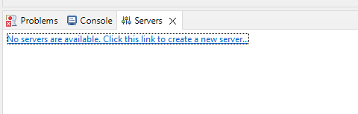

Double click the server you create, in the Server Setting page, choose the second option “Use Tomcat installation” in Server Location options. Ctrl S to save.

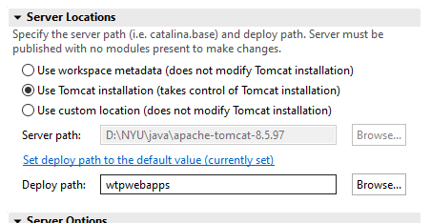

Then right click the server, go to add and remove options, add our project into.

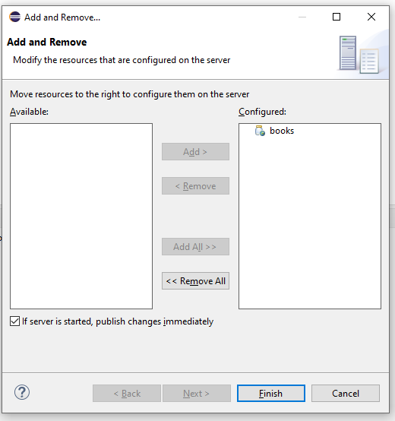

1. Use any Internet browser, go to page: <http://localhost:8080/books> , you can start looking at our project.

User Password for the system: 123456

Admin Password for the system: 123456